



Yenepoya Institute of Arts Science Commerce and
Management, Balmatta
Mangalore

Final Project Report on
Anomaly detection For Healthcare Transaction

Student Name: Safnas A
23BSAMD029
LH08
BSc. Artificial Intelligence,
Machine learning and Data Science(IBM,TCS)

Industry Mentor: Mr. Sumith Kumar Shukla

Guided by: Ankitha Poojary
Department of Computer Science
ACKNOWLEDGEMENT
I express my sincere gratitude to Yenepoya institute of Arts Science Commerce and Management for providing me the opportunity to undertake and successfully complete this final year project titled “Anomaly Detection for Health Care Transactions.”
I would like to convey my heartfelt thanks to my respected project guide Ms. Ankitha Poojary for the valuable guidance, constant encouragement, and support throughout the development of this project.
I extend my sincere thanks to my IBM mentor, Mr. Sumith Kumar Shukla sir for providing industry guidance, technical support, and valuable suggestions during the course of this project. I also thank IBM for offering the platform and resources that contributed to the successful completion of the project.
I also express my gratitude to the Head of the Department and all faculty members for their encouragement and support.
Finally, I thank my parents, family members, and friends for their continuous motivation and moral support.

TABLE OF CONTENTS

1. Executive Summary 4
2. Background 5
3. Aim 6
4. Technologies Used 7
5. Hardware Architecture 8
6. Software Architecture 10
7. System Requirements 12
8. Functional Requirements 13
9. User Requirements 14
10. Environmental Requirements 16
11. Design and Architecture 17
12. Implementation 21
13. Testing 30
14. Graphical User Interface Layout 32
15. Customer Testing 34
16. Evaluation 34
17. Snapshots of the Project 37
18. Conclusions 43
19. Further Development 44
20. References 45
21. Appendix 45-51

- EXECUTIVE SUMMARY

The healthcare industry generates a large number of financial transactions every day in the form of insurance claims, hospital billing records, reimbursements, pharmacy charges, consultation fees, laboratory payments, and patient settlements. Because of the high volume and complexity of these transactions, it becomes difficult for organizations to manually verify every record. As a result, unusual transactions such as duplicate claims, incorrect billing amounts, abnormal reimbursements, and fraudulent entries may remain unnoticed. These issues can lead to financial loss, operational inefficiency, and reduced trust among patients and service providers.

The main purpose of this project, titled Anomaly Detection for Health Care Transactions, is to develop an intelligent system capable of automatically identifying suspicious healthcare claims and abnormal transaction values. The system was developed using Python programming language, Jupyter Notebook for analysis, and Streamlit for creating a simple and interactive web-based interface. The proposed solution uses a statistical anomaly detection technique known as the Z-Score method to identify transactions that significantly deviate from normal claim patterns.

The project begins with loading the healthcare claims dataset stored in CSV format. The dataset is cleaned by removing missing values and invalid claim amounts. After preprocessing, the mean and standard deviation of the claim amount column are calculated. Using these values, a Z-score is generated for each claim transaction. Transactions with a Z-score beyond the accepted threshold are labeled as anomalies and highlighted for further review.

To improve understanding of the results, data visualizations such as histograms and scatter plots are generated. These visual outputs clearly show the distribution of claim amounts and help users identify unusual transactions over time. In addition, a Streamlit application was developed to allow users to upload their own dataset, view processed records, manually enter claim amounts, and instantly check whether the entered transaction is normal or suspicious.

The project demonstrates that even a lightweight statistical model can provide effective anomaly detection when properly implemented. It reduces manual effort, improves monitoring efficiency, and can serve as a foundation for more advanced fraud detection systems in the future.

  - Introduction

The healthcare industry handles a large volume of financial transactions every day, including insurance claims, hospital billing records, laboratory charges, pharmacy bills, consultation fees, and reimbursement payments. As healthcare services continue to expand, the number of digital transactions has increased significantly. Managing and monitoring these transactions manually has become difficult, time-consuming, and inefficient.

In many healthcare systems, abnormal transactions may occur due to data entry mistakes, duplicate claims, excessive billing, unauthorized reimbursements, or fraudulent activities. If such unusual records are not detected at the right time, they may result in financial loss, delayed processing, and reduced trust in the organization. Therefore, healthcare institutions require intelligent systems that can automatically monitor transactions and identify suspicious patterns.

Anomaly detection is a data analysis technique used to find records that differ significantly from normal behavior. It is widely used in fraud detection, cybersecurity, banking, healthcare analytics, and industrial monitoring. In healthcare finance, anomaly detection can help identify unusually high claims, repeated claims, or inconsistent billing patterns.
This project, titled Anomaly Detection for Health Care Transactions, was developed to address these challenges using Python programming language, Jupyter Notebook, and Streamlit. The system analyzes healthcare claims data using the Z-score statistical method and automatically flags suspicious transactions. It also provides graphical reports and a user-friendly dashboard for easy interaction.
The proposed solution helps reduce manual effort, improves transaction monitoring speed, and supports better financial control. It is a practical and low-cost system that can be further enhanced using advanced machine learning methods in the future.

2. BACKGROUND
The healthcare sector is one of the most important industries in modern society. It involves hospitals, clinics, pharmacies, insurance providers, diagnostic laboratories, and other service organizations that process a large number of financial and administrative transactions daily. These transactions include claim submissions, reimbursements, consultation fees, surgery charges, medicine bills, laboratory expenses, and patient payment records.
With the increasing use of digital systems in healthcare management, transaction data is now generated and stored electronically. While digital transformation has improved speed and convenience, it has also introduced new challenges. Errors in data entry, duplicate claims, inflated charges, unnecessary procedures, and intentional fraud can occur within these systems. Since the number of records is often very high, manual auditing becomes expensive, time-consuming, and inefficient.
Traditional auditing systems generally depend on human review or fixed rule-based checks. For example, a claim above a certain amount may be flagged for review. However, such methods are limited because fraud patterns continuously change. Static rules may miss many suspicious activities or generate too many false alarms.
Anomaly detection has emerged as an effective solution to this problem. Anomaly detection is the process of identifying records that behave differently from the majority of normal transactions. In healthcare finance, anomalies may indicate unusual claim amounts, abnormal frequency of claims, suspicious billing behavior, or system errors.
Machine learning and statistical techniques are widely used for anomaly detection. In this project, the Z-score statistical method is used because it is simple, efficient, and effective for identifying extreme values in numerical data. This method compares each claim amount with the overall average claim amount and measures how far it is from normal behavior.
The growing importance of data-driven monitoring in healthcare makes anomaly detection a highly relevant topic. By implementing such systems, healthcare organizations can strengthen financial control, improve transparency, reduce fraud risk, and enhance decision-making processes.

3. AIM
The main aim of this project is to design and develop a smart healthcare transaction monitoring system that can automatically identify abnormal or suspicious claims using statistical anomaly detection techniques.
The project is focused on improving the efficiency of financial transaction monitoring within healthcare organizations by reducing dependency on manual checking methods. The system is intended to assist hospitals, insurance companies, and billing departments in detecting unusual claim values quickly and accurately.
Specific Objectives of the Project
- To develop an automated system for analyzing healthcare claims data.
- To detect unusually high or low transaction amounts using Z-score analysis.
- To reduce the time and effort required for manual auditing.
- To create a user-friendly Streamlit interface for easy interaction.
- To provide graphical reports for better understanding of transaction patterns.
- To export suspicious claim records for future investigation.
- To improve financial transparency and operational control in healthcare systems.
- To create a scalable solution that can be upgraded with machine learning models in the future.
This project aims to prove that even simple statistical methods can provide strong support in detecting suspicious healthcare transactions when implemented effectively

4. TECHNOLOGIES USED
The successful implementation of this project required the use of various software tools, programming libraries, and development platforms. Each technology played an important role in data analysis, anomaly detection, visualization, and user interface development.
Technology | Purpose
Python | Core programming language used to build the project
Pandas | Used for reading CSV files and data manipulation
NumPy | Used for mathematical and numerical calculations
Matplotlib | Used for charts, histograms, and scatter plots
Streamlit | Used to create the web-based user interface
Jupyter Notebook | Used for development, testing, and experimentation
CSV File | Used for storing healthcare claim transaction data
VS Code / Editor | Used for writing and managing project code

Python
Python was selected as the primary programming language because it is simple, powerful, and widely used in data science and machine learning projects. Python supports multiple libraries required for data analysis and visualization.

Pandas
Pandas is used to load and process the claims dataset. It provides powerful functions for cleaning missing values, filtering records, renaming columns, and exporting results.

NumPy
NumPy helps in performing statistical calculations such as mean, standard deviation, and numerical processing required for anomaly detection.

Matplotlib
Matplotlib is used to generate graphical representations of the dataset, such as histograms and scatter plots. These graphs help users understand claim distributions and suspicious activity.

Streamlit
Streamlit allows rapid development of an interactive web application where users can upload files, check anomalies, and view results without writing code.

Jupyter Notebook
Jupyter Notebook was used during project development to test the detection logic, visualize outputs, and verify dataset processing step by step.

5. HARDWARE ARCHITECTURE
The project does not require expensive hardware and can run on a standard computer system. However, better hardware improves speed and performance when working with larger datasets.
Minimum Hardware Requirements:

Component | Specification
Processor | Intel Core i3 or equivalent
RAM | 4 GB
Storage | 500 GB HDD
Display | Standard Monitor
Input Devices | Keyboard and Mouse

Recommended Hardware Requirements:
Component | Specification
Processor | Intel Core i5 / i7
RAM | 8 GB or higher
Storage | SSD Recommended
Display | Monitor

Hardware Working Structure
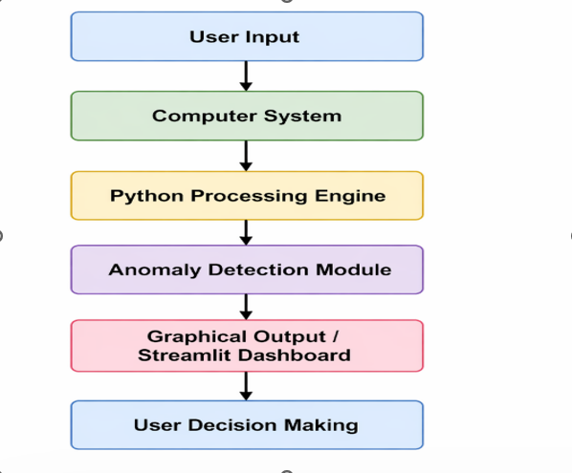

Explanation
The user interacts with the system through a computer. The uploaded healthcare claims dataset is processed by the Python engine. The anomaly detection module analyzes the claim amounts and identifies suspicious transactions. The results are then displayed in graphical and tabular form through the Streamlit dashboard.

6. SOFTWARE ARCHITECTURE
Software architecture defines the internal structure of the system and explains how different software components interact with each other to perform anomaly detection. In this project, the software architecture was designed in a modular manner so that each component performs a specific task. This improves maintainability, scalability, and performance.
The proposed system consists of four major software layers:
- Data Input Layer
- Processing Layer
- Detection Layer
- Presentation Layer

6.1 Data Input Layer
The Data Input Layer is responsible for accepting healthcare transaction data from users. The dataset is provided in CSV format and uploaded through the Streamlit interface. This layer ensures that the input file is read properly and converted into a structured DataFrame using Pandas.
Main tasks of this layer:
- Accept CSV file uploads
- Read data using Pandas
- Validate column names
- Convert charges column to claim_amount if required
- Prepare data for further processing

6.2 Processing Layer
The Processing Layer performs data cleaning and preprocessing. It removes missing values, filters invalid claim amounts, and prepares numerical data for anomaly detection.
Main tasks:
- Remove null values
- Remove zero or negative claim amounts
- Standardize column names
- Create cleaned dataset

6.3 Detection Layer
This is the core layer of the project. It calculates mean and standard deviation of claim amounts, computes Z-scores, and labels abnormal transactions.
Main tasks:
- Calculate average claim amount
- Calculate standard deviation
- Generate Z-score for each record
- Mark anomalies where |Z| > 3

6.4 Presentation Layer
This layer displays the final output to the user using Streamlit. It shows processed data, anomalies, graphs, and manual input results.
Main tasks:
- Display uploaded dataset
- Show anomaly records
- Display success/warning alerts
- Generate charts
- Provide interactive interface

Software Architecture Diagram:
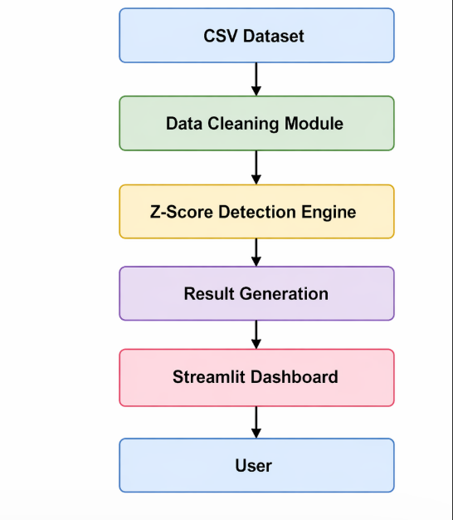
The modular architecture makes the project easy to understand and allows future upgrades such as adding machine learning algorithms or cloud deployment.

7. SYSTEM REQUIREMENTS
System requirements define the necessary hardware and software resources required to run the project successfully.

7.1 Hardware Requirements

Component | Minimum Requirement | Recommended
Processor | Intel i3 | Intel i5 / i7
RAM | 4 GB | 8 GB or more
Storage | 500 GB HDD | SSD
Monitor | Standard | Full HD
Internet | Optional | Recommended

7.2 Software Requirements
Software | Version
Operating System | Windows 10 / 11
Python | 3.x
Streamlit | Latest
Jupyter Notebook | Latest
Pandas | Latest
NumPy | Latest
Matplotlib | Latest

7.3 Dataset Requirements
- CSV format dataset
- Claim amount column mandatory
- Clean structured data preferred
- Reasonable number of rows for faster processing

7.4 Performance Requirements
- Fast file upload
- Quick anomaly detection
- Smooth GUI interaction
- Accurate output generation
The system requirements are minimal, making the project cost-effective and easy to deploy in small or large organizations.

8. FUNCTIONAL REQUIREMENTS
Functional requirements describe what the system should do. These are the core operations that must be supported by the healthcare anomaly detection system.
Main Functional Requirements

8.1 File Upload Function
The user should be able to upload a healthcare transaction CSV file through the Streamlit application.

8.2 Dataset Reading
The system should read the uploaded file and convert it into a usable tabular format.

8.3 Data Cleaning
The system should remove missing values and invalid records before analysis.

8.4 Column Conversion
If the uploaded dataset contains a column named charges, the system should automatically rename it to claim_amount.

8.5 Anomaly Detection
The system should calculate Z-score values and identify suspicious records.

8.6 Result Display
The system should display processed data and anomalies separately.

8.7 Manual Input Check
Users should be able to manually enter a claim amount and instantly verify whether it is normal or suspicious.

8.8 Graph Generation
The system should generate visual reports such as histograms and scatter plots.

8.9 Export Results
The system should allow saving processed records and suspicious claims into CSV files.
These requirements ensure that the system performs all major tasks needed for practical anomaly monitoring.

9. USER REQUIREMENTS
User requirements explain the expectations and needs of the people who will use the system. Different users may interact with the project for different purposes.
Types of Users

9.1 Hospital Billing Staff
Need quick verification of claim amounts before approval.

9.2 Insurance Auditors
Need suspicious claims for further investigation.

9.3 Finance Managers
Need summary reports and financial control monitoring.

9.4 Data Analysts
Need processed data for trend analysis.
9.5 Students / Researchers
Need a working anomaly detection model for learning purposes.

User Expectations
- Easy to use interface
- Fast response time
- Clear anomaly alerts
- Accurate results
- No technical complexity
- Exportable reports

User Benefits
- Saves time
- Reduces manual work
- Improves accuracy
- Helps decision making
- Increases transparency
The system was designed with simplicity in mind so that even non-technical users can operate it easily.

10. ENVIRONMENTAL REQUIREMENTS
Environmental requirements describe the surroundings and operating conditions necessary for successful use of the system.

10.1 Physical Environment
- Office or laboratory environment
- Clean workspace
- Proper electricity supply
- Comfortable temperature for computer systems

10.2 Technical Environment
- Computer or laptop
- Installed Python environment
- Required software libraries
- Secure storage for datasets

10.3 Network Environment
- Internet connection for downloading libraries
- Optional network access for sharing reports

10.4 Security Environment
Healthcare data may contain sensitive information. Therefore:
- Access should be restricted
- Files should be stored securely
- Unauthorized sharing should be avoided
- Backup copies should be maintained

10.5 Maintenance Environment
- Periodic software updates
- Antivirus protection
- Data backups
- Performance monitoring
A suitable environment ensures smooth project execution and long-term usability.

11. DESIGN AND ARCHITECTURE
System design is one of the most important phases of project development. It explains how the proposed healthcare anomaly detection system is structured, how data flows through the system, and how each module interacts with another. A well-designed architecture improves performance, maintainability, and scalability.
The project was designed using a modular architecture so that each component performs a separate task. This makes the system easier to test, debug, and enhance in the future.
11.1 Main Modules of the System
The project consists of the following modules:
- Dataset Input Module
- Data Preprocessing Module
- Anomaly Detection Module
- Visualization Module
- Streamlit GUI Module
- Export and Reporting Module

11.2 Dataset Input Module
This module is responsible for reading the healthcare transaction data stored in CSV format. The user uploads the file through the Streamlit application, and the system converts it into a structured DataFrame using Pandas.
Functions performed:
- Accept CSV upload
- Validate file type
- Read data records
- Display top rows of dataset

11.3 Data Preprocessing Module
Before analysis, the dataset must be cleaned and standardized.
Functions performed:
- Remove missing values
- Remove negative or zero claim amounts
- Rename charges column to claim_amount if necessary
- Prepare clean data for processing

11.4 Anomaly Detection Module
This is the core engine of the project. It uses the Z-score statistical technique to identify suspicious claims.
The core functionality of the project is implemented using the Z-score statistical method. Z-score is used to measure how far a healthcare claim amount is from the average claim amount in the dataset. It helps in identifying unusually high or low transactions that may indicate fraud, duplicate billing, or abnormal reimbursement activity.
In this project, the claim amount column from the uploaded dataset is selected for analysis. First, the system calculates the mean (average) of all claim values. Then, the standard deviation is calculated to understand how much the values vary from the mean.

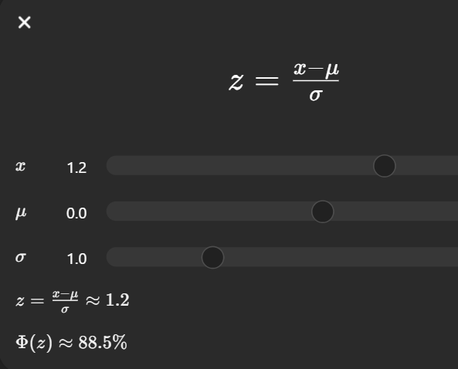

Where:
- x = claim amount
- μ = mean claim amount
- σ = standard deviation
If the absolute Z-score is greater than 3, the transaction is considered suspicious.
$$∣z∣>3$$

11.5 Visualization Module
This module provides graphical insights for better understanding.
Graphs included:

- Scatter plot of claims over time
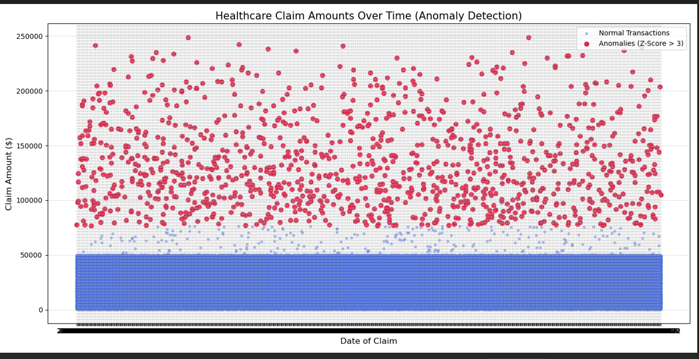

- Highlighted anomaly points
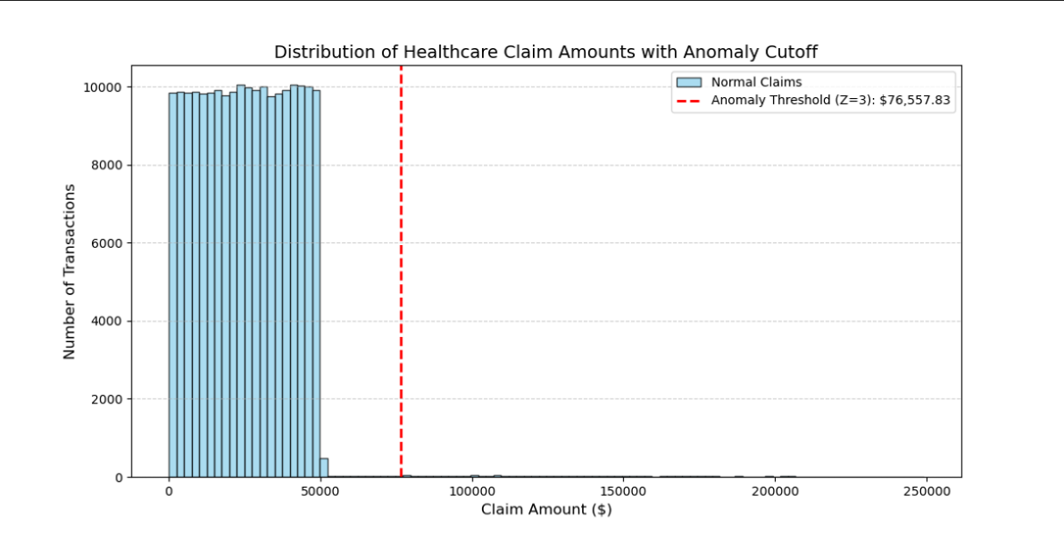

11.6 GUI Module
Developed using Streamlit. Allows users to interact with the project without coding knowledge.
Features:
- Upload dataset
- View processed data
- Check anomalies
- Manual claim amount input
- Alert messages

11.7 System Architecture Diagram
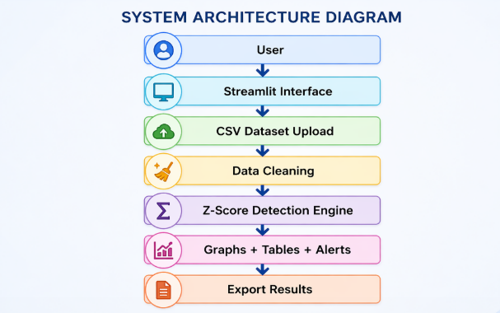

11.8 Data Flow Diagram
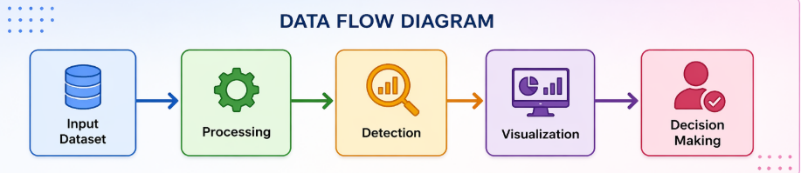

12. IMPLEMENTATION
Implementation is the process of converting system design into an actual working application. In this project, implementation was completed using Python, Jupyter Notebook, and Streamlit.
The project contains the following source files:
- test.ipynb – analysis and graph generation
- app.py – Streamlit interface
- anomaly_detection.py – anomaly logic
- claims.csv – dataset file

The implementation process begins when the user uploads a healthcare claims dataset through the Streamlit interface. The uploaded file is validated and read into a Pandas DataFrame. This structured format allows smooth data manipulation and statistical analysis.
After loading the dataset, preprocessing is performed to remove missing values and invalid transactions. Clean data ensures accurate anomaly detection and prevents misleading outputs.
The cleaned dataset is then passed to the Z-score engine, where each claim amount is compared with the average transaction behavior. Suspicious records are marked and displayed to the user.
Finally, the results are shown through tables, charts, and alert messages. CSV files are also generated for future review.
The project consists of multiple modules such as app.py, anomaly_detection.py, dataset files, and visualization outputs. All modules work together to provide a complete anomaly detection system.
The Streamlit interface acts as the front-end layer, while Python scripts perform backend processing. This modular architecture improves maintainability and scalability.

12.1 Importing Required Libraries & Load Dataset
The first stage of implementation is loading the healthcare claims dataset into the Python environment. The dataset is stored in CSV format and contains healthcare transaction records. The Pandas library is used because it provides fast and efficient data handling functions.
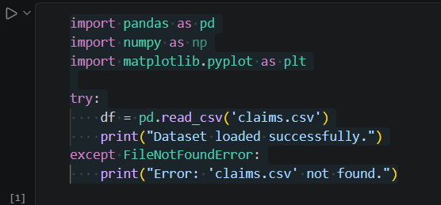
This command reads the dataset and converts it into a DataFrame. A DataFrame is a tabular data structure with rows and columns. It allows filtering, cleaning, and statistical operations.
Purpose of this step:
- Import transaction records
- Prepare data for processing
- Enable structured analysis

Explanation
- Pandas is used for dataset handling.
- NumPy is used for calculations.
- Matplotlib is used for graphs.
- Streamlit is used for the user interface.
- This line reads the healthcare transactions dataset.
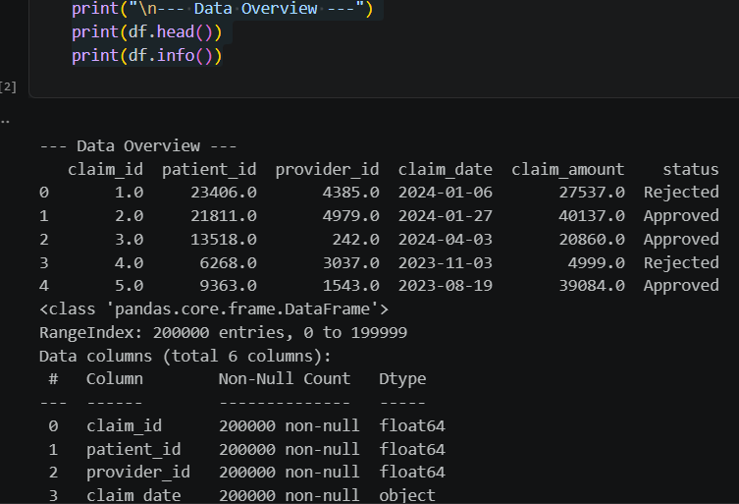
The head() function displays the first five rows of the dataset. The info() function shows the number of rows, columns, and datatype of each column.
This helps in understanding:
- Which columns are available
- Missing values
- Numeric and text fields
- Total records

12.2 Cleaning Dataset & Mean and Standard Deviation
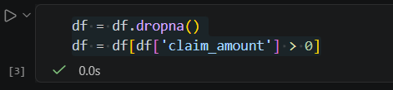
The dropna() function removes rows with empty values. The second line removes transactions where claim amount is zero or negative.
This improves accuracy because anomaly detection should only be performed on valid financial data.

Removes:
- Missing values
- Invalid zero claim amounts
- Negative claim values
Mean and standard deviation Used for Z-score calculations.

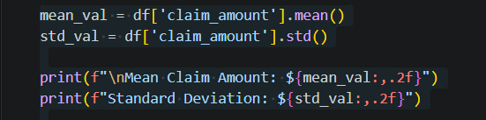
The mean represents the central value of the claims. Standard deviation shows how spread out the values are.
These values are required for Z-score calculation.

12.3 Z-Score Calculation

The core logic of anomaly detection is implemented in this stage.
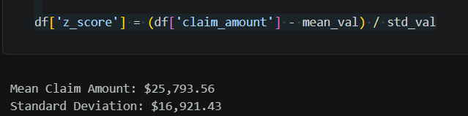
If the Z-score is high, it means the claim amount is far from normal values.
Working Process
- Read the claim amount values from dataset.
- Compute mean and standard deviation.
- Calculate Z-score for every row.
- Compare score with threshold.
- Mark suspicious transactions as anomaly = 1.
- Display results in dashboard and export CSV files.
Advantages of Using Z-Score
- Fast and easy to implement
- Works well for numeric transaction values
- Suitable for academic prototype systems
- Helps detect extreme claim amounts instantly
- Low computational cost
Output of This Module
The output generated by this module includes:
- Claim amount
- Z-score value
- Anomaly label (0 = Normal, 1 = Suspicious)
These results are displayed in the Streamlit dashboard and stored in exported CSV files for further review.

12.4. Identifying Anomalies
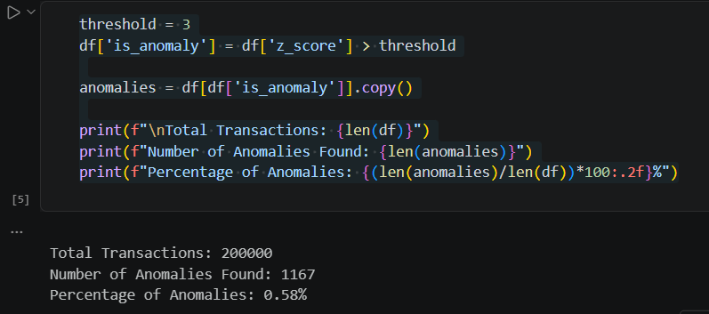
Transactions above threshold are suspicious.

12.5. Visualization
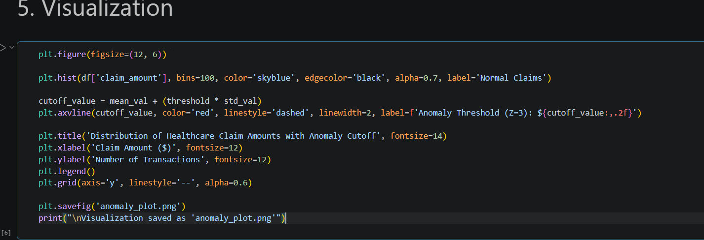
Used to show claim distribution.



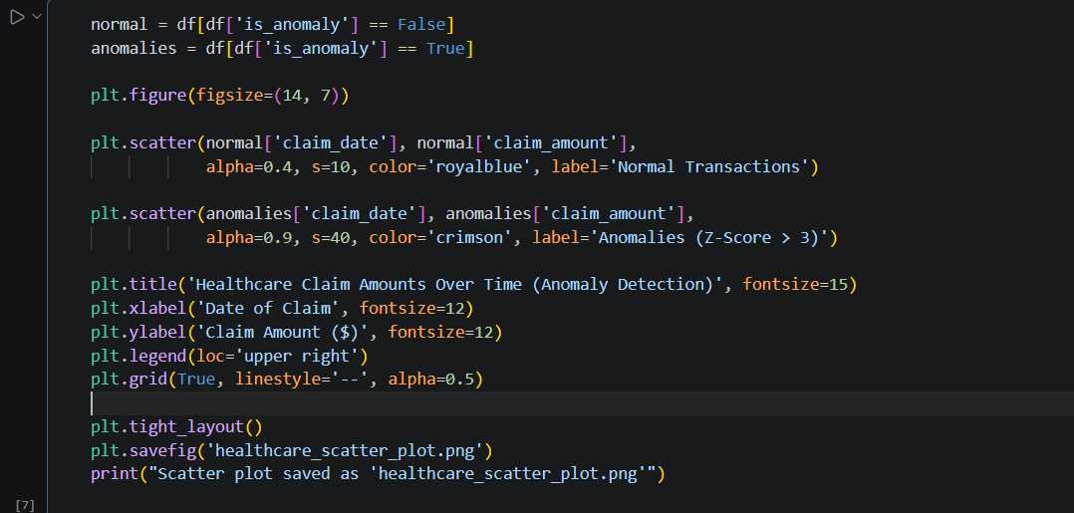
Used to show anomalies over time.

12.6.Export Results
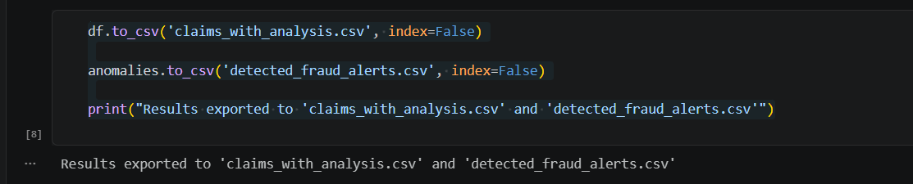
Exports processed and suspicious claims.
This helps auditors review suspicious transactions later.

12.7.Streamlit Application
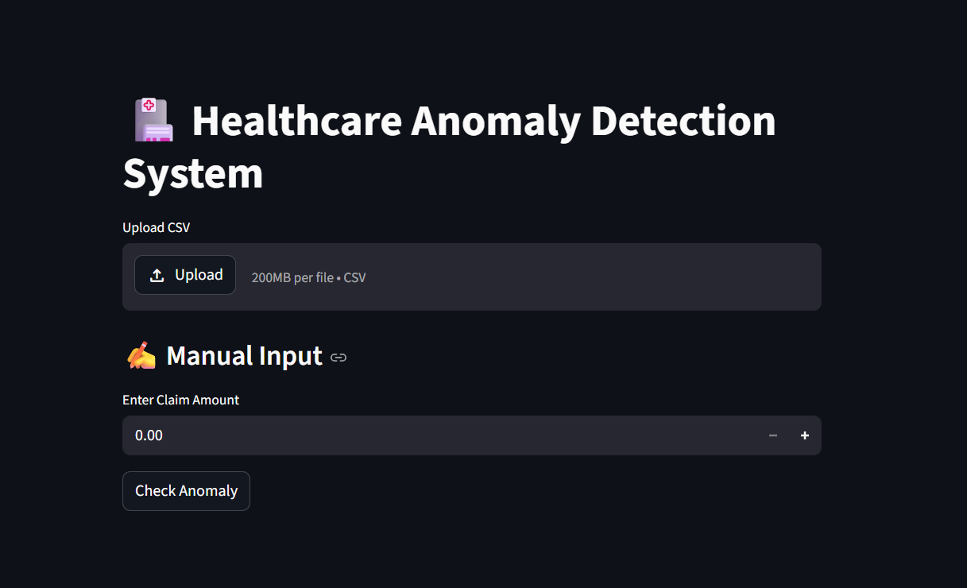
Provides interactive dashboard.

12.8 Streamlit File Upload Process
The Streamlit application provides an easy-to-use upload feature through which users can select a healthcare claims CSV file from their computer. Once the file is uploaded, the system reads the file using Pandas and converts it into a DataFrame for further processing. This removes the need for manual coding and allows non-technical users to interact with the system efficiently.

12.9 Manual Claim Verification Module
The manual claim verification section allows users to enter any claim amount through the input box. After clicking the Check Anomaly button, the entered value is appended to the current dataset and analyzed using the anomaly detection model. If the value is unusual compared to existing transactions, the system displays an anomaly warning message.

12.10 Result Export Process
After analysis, the processed dataset and suspicious claim records are exported into CSV format. These exported files help finance teams, hospital auditors, and insurance reviewers to maintain records and conduct further investigation whenever required.

12.11.System Execution Flow
The complete execution of the system starts when the user launches the Streamlit application. After opening the interface, the user uploads a healthcare claims dataset in CSV format. The uploaded data is immediately read by the backend Python engine and stored in a DataFrame for processing.
The application then checks whether the required claim amount column exists. If another name such as charges is found, the system automatically renames it to maintain compatibility. This improves usability and reduces manual correction work.
Once validation is completed, the anomaly detection function is called. The dataset is processed row by row, statistical calculations are performed, and anomaly labels are assigned. Finally, the results are displayed in tables and alerts on the dashboard.

12.12. Statistical Processing Module
The statistical module is responsible for calculating the average transaction amount and measuring deviation among all claim values. This helps in identifying how far each transaction is from the normal range.
The mean value acts as the center point of all claims, while the standard deviation measures variation. Transactions with very high deviation are considered suspicious. This method is simple, fast, and effective for academic prototype systems.

12.13. Output Generation Module
After successful processing, the system produces multiple forms of output. These include anomaly tables, graphs, downloadable CSV files, and instant alert messages.
The generated outputs are useful for healthcare administrators because they can review suspicious claims quickly without checking thousands of records manually. This saves time and improves operational efficiency.

13. TESTING
Testing ensures the system works correctly under different conditions.

13.1 Unit Testing
Test Case | Expected Result | Status
Upload valid CSV | File loads successfully | Pass
Missing file | Error message shown | Pass
Manual input normal amount | Normal result shown | Pass
Manual input extreme amount | Anomaly detected | Pass

The testing phase confirmed that the system performs correctly under different scenarios. Both normal and abnormal transactions were identified accurately, and the interface responded properly to invalid input conditions.

13.2 Integration Testing
Verified interaction between:
- CSV upload and processing
- Detection module and GUI
- Graph generation and display
Status: Successful
13.3 Performance Testing
- Dataset of 500 rows processed quickly
- Fast manual anomaly checking
- Smooth UI response

13.4 Accuracy Validation
Known extreme values added:
- 100000
- 200000
- 500000
- 1000000
System correctly flagged them as anomalies.

13.5 Error Handling Testing
- Missing dataset file
- Wrong column names
- Empty input
All handled with warnings.

13.6 Performance Testing
Performance testing was conducted to verify whether the system can process a moderate dataset within a short time. The application successfully handled several hundred rows without delay. Streamlit loaded the interface quickly and generated outputs efficiently.
This proves that the developed system is suitable for small and medium-scale healthcare datasets used in academic and demonstration environments.
13.7 Reliability Testing
Reliability testing ensures that the system produces consistent results when the same dataset is tested multiple times. During repeated execution, the same anomalies were identified correctly based on the Z-score threshold.
This confirms that the implemented logic is stable and dependable.

14. GRAPHICAL USER INTERFACE (GUI) LAYOUT
The project interface was developed using Streamlit.
Main GUI Components
- Title Banner
- CSV Upload Section
- Processed Data Table
- Anomaly Records Table
- Manual Claim Input Box
- Check Anomaly Button
- Alert Output Section

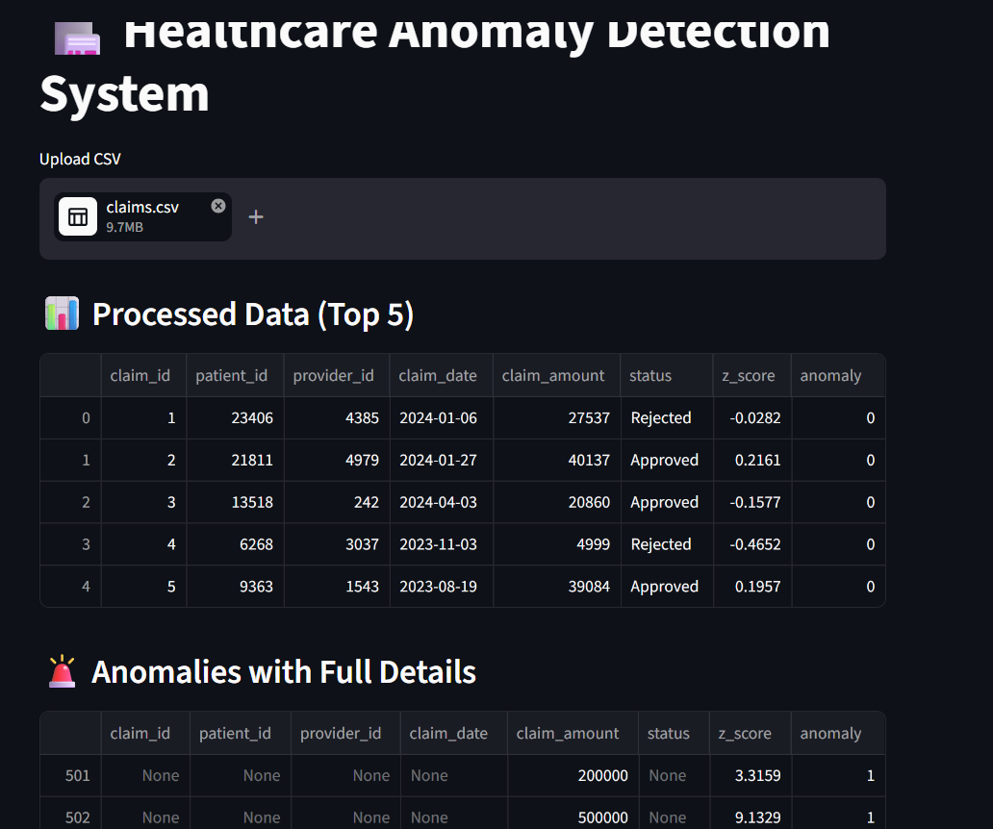

14.GUI Workflow:

14.1 User Interface Design
The graphical user interface was designed using Streamlit with a simple and professional layout. The title section clearly displays the project name, while the upload section helps users provide datasets quickly.

14.2 Interactive Components
The interface contains interactive components such as file uploader, number input field, anomaly checking button, warning messages, success alerts, and data tables. These controls improve usability and provide quick responses.

14.3 Benefits of GUI
The GUI removes command-line complexity and allows healthcare staff to use the system without programming knowledge. It also improves presentation quality during demonstrations.
14.4 Dashboard Experience
The dashboard presents results in a clean tabular format. Users can quickly inspect processed rows, anomaly flags, and suspicious claims without using any programming commands.
14.5 Manual Claim Analysis
The manual input feature is especially useful when a staff member wants to verify a single claim amount instantly. This improves practical usability in real environments.
14.7 Visual Design Features
The graphical interface was designed with simplicity and clarity as the main objectives. Proper headings, icons, buttons, and spacing were used to make the dashboard user-friendly.
The use of organized sections allows users to navigate between upload options, result tables, and manual claim verification smoothly.
14.8 User Experience Benefits
A simple interface improves productivity because users can perform anomaly checks without learning programming commands. Healthcare staff can upload files, inspect anomalies, and make decisions with minimal training.
This makes the solution practical for real-world non-technical users.

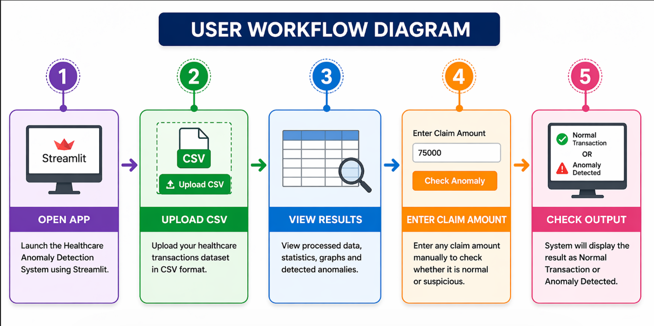
Advantages of GUI
- Easy to use
- No coding required
- Fast interaction
- Clear results
- Professional presentation

15. CUSTOMER TESTING

User Type | Feedback
Billing Staff | Easy to understand
Auditor | Useful for suspicious claims
Student | Good learning project
Faculty Reviewer | Practical implementation

Common Suggestions
- Add login page
- Add more graphs
- Add real-time alerts
- Connect database
Overall Response
Users found the project simple, useful, and effective for anomaly monitoring.

16. EVALUATION
Evaluation is the process of measuring the effectiveness, usability, and overall performance of the developed system. The healthcare anomaly detection project was evaluated based on functionality, accuracy, speed, user experience, and practical usefulness. The results indicate that the proposed system successfully meets its objectives.
16.1 Functional Evaluation
The system was tested to verify whether all required functions were working correctly. The following features were implemented successfully:
- Uploading healthcare transaction datasets in CSV format
- Reading and displaying dataset records
- Cleaning missing or invalid data
- Detecting suspicious claims using Z-score method
- Displaying anomaly records separately
- Manual claim amount checking
- Generating graphs and visual reports
- Exporting processed results to CSV files
All major functional requirements were achieved successfully.

16.2 Performance Evaluation
The project was designed as a lightweight application. It was tested using sample datasets and demonstrated fast performance.
Evaluation Parameter | Result
File Upload Speed | Fast
Data Processing Speed | Fast
Detection Speed | Instant
GUI Response Time | Smooth
Export Time | Fast

The use of statistical methods instead of heavy machine learning algorithms helped improve speed and simplicity.

16.3 Accuracy Evaluation
The system was evaluated using manually inserted extreme claim values such as:
- 100000
- 200000
- 500000
- 1000000
These values were successfully detected as anomalies. This confirms that the system can identify unusual transactions that significantly differ from the normal dataset distribution.

16.4 User Evaluation
Users who tested the project found the interface easy to understand. Non-technical users were able to upload files and interpret results without difficulty.

16.5 Overall Evaluation
The project performed well in all major categories and proved to be a practical academic solution for healthcare transaction anomaly monitoring.

Advantages
- Reduces manual effort
- Detects unusual claims quickly
- User friendly GUI
- Good academic project
Limitations
- Uses one column mainly
- No real-time database
- Needs cleaner datasets

16.6 Practical Importance
This project is practically useful for hospitals, clinics, insurers, and finance departments. It reduces the time required for manual review and supports faster decision-making. Even with a lightweight statistical model, the system provides meaningful insights.

16.7 Accuracy Observation
The system correctly identified extreme claim values inserted into the dataset. Manual verification showed that very high claim amounts were flagged as anomalies, while normal transactions remained unflagged.
Although this project uses a statistical method rather than advanced machine learning, it still provides meaningful results for suspicious claim detection.
16.8 Cost Effectiveness
The developed system is highly cost-effective because it uses open-source tools such as Python, Pandas, Matplotlib, and Streamlit. No expensive software licenses are required.
This makes the project suitable for educational institutions, startups, and small healthcare organizations.

16.9 Real World Benefits
The developed system can be useful in hospitals, insurance firms, clinics, and healthcare finance departments. It can automatically monitor claims and reduce manual workload.
By identifying suspicious billing amounts early, organizations can improve financial control and reduce revenue leakage. Even as a prototype, the project demonstrates practical value.

17. SNAPSHOTS OF THE PROJECT
This chapter contains screenshots and visual evidence of project execution. Insert the following screenshots in your Word report.

17.1 Project Folder Structure
app.py
anomaly_detection.py
test.ipynb
claims.csv
anomaly_plot.png
healthcare_scatter_plot.png
claims_with_analysis.csv
detected_fraud_alerts.csv png
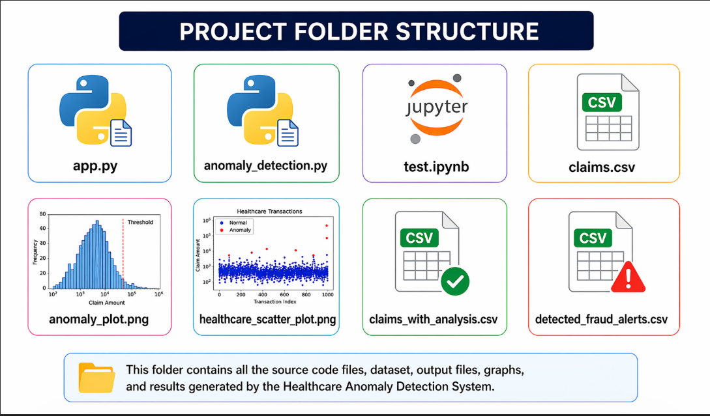

17.2 Dataset Preview
df.head()
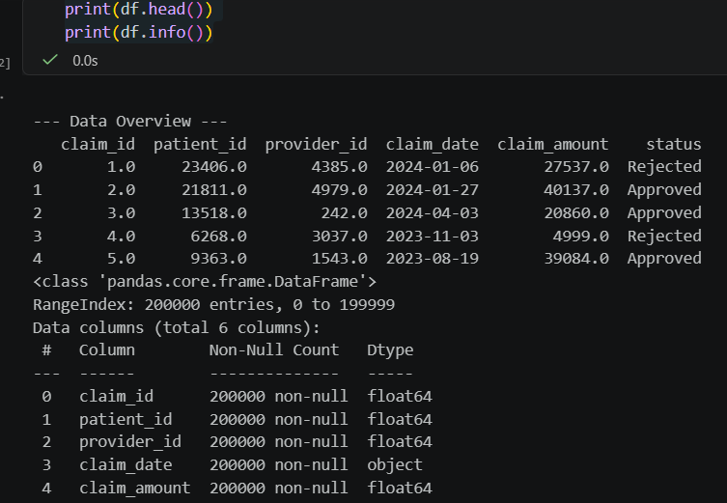
Shows first five rows of claims dataset.

17.3 Data Information

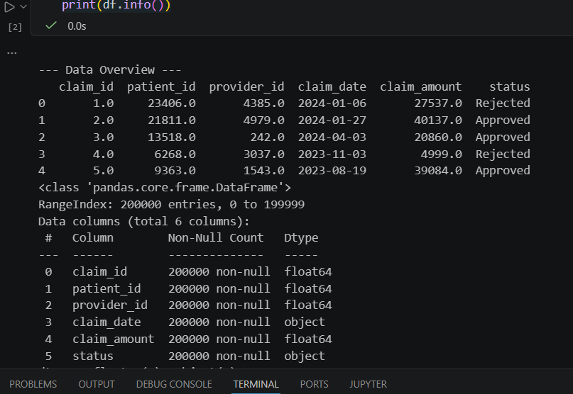
Shows number of rows, columns, and datatypes.

17.4 Histogram Output

anomaly_plot.png


The histogram graph displays the frequency distribution of healthcare claim amounts. Most normal claims remain within a common range, while extreme values are separated using the anomaly threshold line. This helps users visually understand abnormal claim behavior.

17.5 Scatter Plot Output

healthcare_scatter_plot.png

The scatter plot visually represents healthcare claim amounts across time and highlights suspicious transactions in a different color. It helps users quickly identify abnormal spikes and irregular billing behavior.

17.6 Streamlit Home Page

- Title banner
- Upload button
- Data display area



17.7 Manual Input Result

- Enter claim amount
- Check anomaly button
- Result message

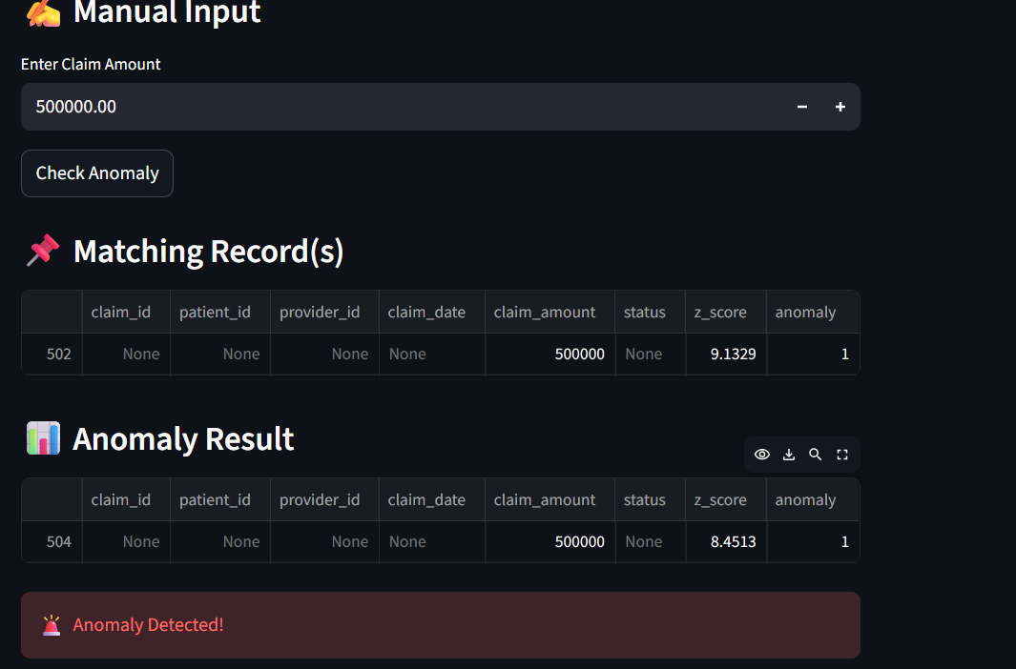

17.8 Exported CSV Files
claims_with_analysis.csv:
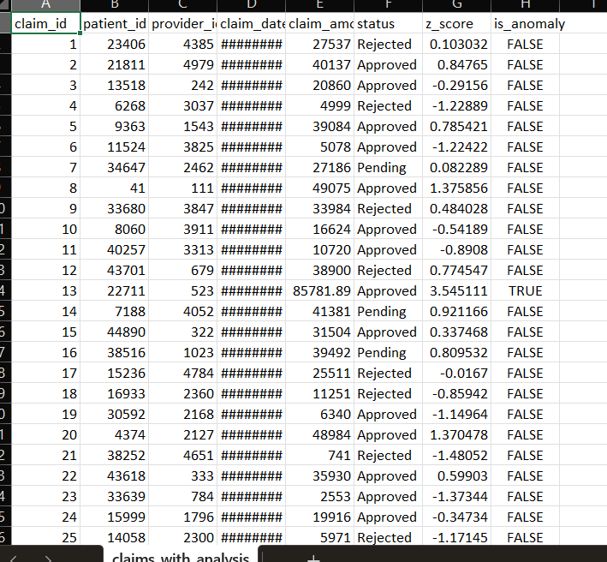
detected_fraud_alerts.csv:
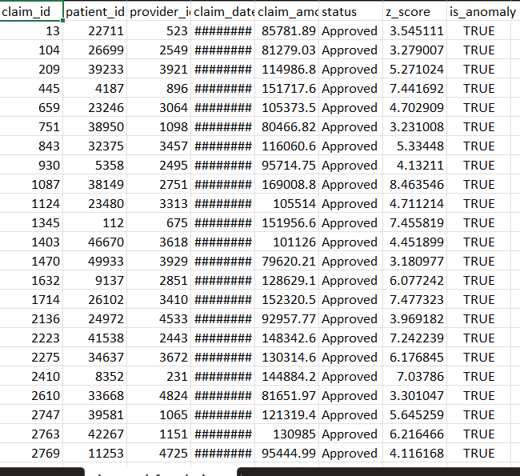

18. CONCLUSIONS
The project Anomaly Detection for Health Care Transactions was successfully designed and implemented using Python, Jupyter Notebook, and Streamlit. The system demonstrates how data analytics and statistical methods can be used to identify suspicious healthcare claim transactions efficiently.
The developed solution uses the Z-score technique to compare claim amounts with the normal behavior of the dataset. Transactions with significantly unusual values are automatically flagged as anomalies. This helps organizations quickly identify records that may require further review.
The project titled Anomaly Detection for Health Care Transactions was successfully designed and implemented. The system demonstrates how healthcare financial records can be analyzed automatically using statistical anomaly detection techniques.

By integrating Python-based analytics with a modern Streamlit interface, the project becomes both technically effective and easy to use. It can help identify abnormal claim amounts, reduce manual workload, and support better monitoring practices.
The project also provides a strong foundation for future enhancement using machine learning, cloud storage, and real-time hospital databases.

The Streamlit interface adds practical value by allowing users to upload datasets, view anomalies, and manually test claim amounts in real time. The graphical outputs further improve understanding of claim patterns and suspicious activities.
The project successfully demonstrates how anomaly detection can be applied to healthcare financial transactions using Python. By combining statistical methods with a graphical user interface, the system becomes practical, efficient, and user-friendly. It can help organizations reduce billing irregularities, identify suspicious claims, and improve monitoring efficiency.

The project achieved the main objectives of reducing manual effort, improving monitoring speed, and creating a user-friendly anomaly detection platform. It also provides a strong foundation for future expansion using advanced machine learning techniques.
Overall, the project is academically valuable and practically relevant in the field of healthcare analytics.

19. FURTHER DEVELOPMENT
Although the current system performs effectively, several improvements can be added in the future.
In future versions, the system can be integrated with hospital management software and insurance claim platforms. Real-time transactions can be monitored continuously.
Machine learning models such as Isolation Forest, Random Forest, and Neural Networks can improve anomaly detection accuracy. Additional features such as login authentication, report downloads, SMS alerts, and cloud dashboards can also be implemented.
19.1 Advanced Enhancements
Future versions of the project can include machine learning models such as Isolation Forest, Local Outlier Factor, and Random Forest for more accurate anomaly detection.
Cloud deployment can allow remote access, while database integration can enable real-time transaction monitoring. Alert notifications through email or SMS can further improve usability.

Possible Enhancements
- Use Machine Learning algorithms such as Isolation Forest or Random Forest.
- Add real-time monitoring of live transactions.
- Connect with SQL database systems.
- Add user login and authentication.
- Send email or SMS alerts for suspicious claims.
- Add advanced dashboards using Power BI.
- Support multiple anomaly detection methods.
- Deploy system on cloud platforms.
- Add role-based access for hospitals and insurers.
- Improve fraud scoring accuracy with historical data.
These enhancements can convert the project into an enterprise-level fraud detection solution.

20. REFERENCES
- Python Official Documentation – https://www.python.org/
- Pandas Documentation – https://pandas.pydata.org/
- NumPy Documentation – https://numpy.org/
- Matplotlib Documentation – https://matplotlib.org/
- Streamlit Documentation – https://streamlit.io/
- Healthcare fraud analytics research papers
- Statistical anomaly detection journals
- Data science textbooks and online references

21. APPENDIX
This chapter includes additional supporting materials.

- Appendix A – app.py
- import streamlit as st
- import pandas as pd
- from anomaly_detection import detect_anomalies

- st.title("🏥 Healthcare Anomaly Detection System")

- # ---------------- FILE UPLOAD ----------------
- uploaded_file = st.file_uploader("Upload CSV", type=["csv"])

- if uploaded_file is not None:
- df = pd.read_csv(uploaded_file)

- # 🔥 Limit data for speed
- df = df.head(500)

- # Fix column name
- if 'charges' in df.columns:
- df.rename(columns={'charges': 'claim_amount'}, inplace=True)

- # 🔥 Add extreme values (ensure anomalies)
- extra = pd.DataFrame({
- 'claim_amount': [100000, 200000, 500000, 1000000]
- })
- df = pd.concat([df, extra], ignore_index=True)

- # Run anomaly detection
- result = detect_anomalies(df)

- # ---------------- DISPLAY DATA ----------------
- st.subheader("📊 Processed Data (Top 5)")
- st.write(result.head())

- # ---------------- ANOMALIES ----------------
- st.subheader("🚨 Anomalies with Full Details")
- anomalies = result[result['anomaly'] == 1]
- st.write(anomalies.head())

- # ---------------- MANUAL INPUT ----------------
- st.subheader("✍️ Manual Input")

- claim_amount = st.number_input("Enter Claim Amount", min_value=0.0)

- if st.button("Check Anomaly"):
- if uploaded_file is not None:

- # 🔍 Search matching records
- matched = df[df['claim_amount'] == claim_amount]

- if not matched.empty:
- st.subheader("📌 Matching Record(s)")
- st.write(matched)
- else:
- st.warning("No exact match found in dataset")

- # 🚨 Anomaly detection
- df_manual = df.copy()
- new_row = pd.DataFrame({'claim_amount': [claim_amount]})
- df_manual = pd.concat([df_manual, new_row], ignore_index=True)

- result_manual = detect_anomalies(df_manual)
- last = result_manual.tail(1)

- st.subheader("📊 Anomaly Result")
- st.write(last)

- if last['anomaly'].values[0] == 1:
- st.error("🚨 Anomaly Detected!")
- else:
- st.success("✅ Normal Transaction")

- else:
- st.warning("⚠️ Please upload dataset first")

Appendix B – anomaly_detection.py

- import pandas as pd

- def detect_anomalies(df):
- df['z_score'] = (df['claim_amount'] - df['claim_amount'].mean()) / df['claim_amount'].std()
- df['anomaly'] = df['z_score'].apply(lambda x: 1 if abs(x) > 3 else 0)
- return df

Appendix C – test.ipynb main code

import pandas as pd
import numpy as np
import matplotlib.pyplot as plt

try:
df = pd.read_csv('claims.csv')
print("Dataset loaded successfully.")
except FileNotFoundError:
print("Error: 'claims.csv' not found.")
print("\n--- Data Overview ---")
print(df.head())
print(df.info())
df = df.dropna()
df = df[df['claim_amount'] > 0]
mean_val = df['claim_amount'].mean()
std_val = df['claim_amount'].std()

print(f"\nMean Claim Amount: ${mean_val:,.2f}")
print(f"Standard Deviation: ${std_val:,.2f}")

df['z_score'] = (df['claim_amount'] - mean_val) / std_val
threshold = 3
df['is_anomaly'] = df['z_score'] > threshold

anomalies = df[df['is_anomaly']].copy()

print(f"\nTotal Transactions: {len(df)}")
print(f"Number of Anomalies Found: {len(anomalies)}")
print(f"Percentage of Anomalies: {(len(anomalies)/len(df))*100:.2f}%")
plt.figure(figsize=(12, 6))

plt.hist(df['claim_amount'], bins=100, color='skyblue', edgecolor='black', alpha=0.7, label='Normal Claims')

cutoff_value = mean_val + (threshold * std_val)
plt.axvline(cutoff_value, color='red', linestyle='dashed', linewidth=2, label=f'Anomaly Threshold (Z=3): ${cutoff_value:,.2f}')

plt.title('Distribution of Healthcare Claim Amounts with Anomaly Cutoff', fontsize=14)
plt.xlabel('Claim Amount ($)', fontsize=12)
plt.ylabel('Number of Transactions', fontsize=12)
plt.legend()
plt.grid(axis='y', linestyle='--', alpha=0.6)

plt.savefig('anomaly_plot.png')
print("\nVisualization saved as 'anomaly_plot.png'")
normal = df[df['is_anomaly'] == False]
anomalies = df[df['is_anomaly'] == True]

plt.figure(figsize=(14, 7))

plt.scatter(normal['claim_date'], normal['claim_amount'],
alpha=0.4, s=10, color='royalblue', label='Normal Transactions')

plt.scatter(anomalies['claim_date'], anomalies['claim_amount'],
alpha=0.9, s=40, color='crimson', label='Anomalies (Z-Score > 3)')

plt.title('Healthcare Claim Amounts Over Time (Anomaly Detection)', fontsize=15)
plt.xlabel('Date of Claim', fontsize=12)
plt.ylabel('Claim Amount ($)', fontsize=12)
plt.legend(loc='upper right')
plt.grid(True, linestyle='--', alpha=0.5)

plt.tight_layout()
plt.savefig('healthcare_scatter_plot.png')
print("Scatter plot saved as 'healthcare_scatter_plot.png'")
df.to_csv('claims_with_analysis.csv', index=False)

anomalies.to_csv('detected_fraud_alerts.csv', index=False)

print("Results exported to 'claims_with_analysis.csv' and 'detected_fraud_alerts.csv'")
print("\n--- Top 10 Suspected Transactions (Highest Z-Scores) ---")
print(anomalies.sort_values(by='z_score', ascending=False).head(10))

Appendix D – Output Files

detected_fraud_alerts.csv claims_with_analysis.csv


